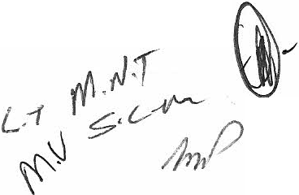MOHOKARE LOCAL MUNICIPALITY PERFORMANCE MANAGEMENT
(Period: 1July 2012- 30 June 2013)

1. PARTIES

The parties to this agreement are -

Mohokare Local Municipality herein represented by Thabo Christian Panyani in his capacity as the
Municipal Manager (hereinafter referred to as "the Employer");

And

Mahlomola Naftali Tsoamotse in his capacity as the Director: Technical Services (hereinafter referred
as "the Employee")

WHEREBY IT IS AGREED AS FOLLOWS:

INTRODUCTION

  - The parties have entered into an employment contract in terms of section 57(1) (a) of the Local Government: Municipal Systems Act No. 32 of 2000 (hereinafter referred to as "the Systems Act").

  - Section 57(1)(b) of the Systems Act, read with the employment contract entered into by parties, requires the parties to annually conclude a performance agreement one month after the beginning of the financial year of the municipality.

  - The parties wish to ensure that they are clear about the goals to be achieved and secure the commitment of the Employee to a set of outcomes that will secure local government policy goals.

  - The parties wish to ensure that there is compliance with sections 57(4A), 57(4B) and 57(5) of the Systems Act.

PURPOSE OF THIS AGREEMENT AND APPENDICES

The purpose of this agreement is to -

  - Comply with the provisions of Sec 57(1) (b), (4A), (4B) and (5) of the Systems Act as well as the Contract of Employment entered into between the parties

  - Specify objectives and targets established for the Employee and to communicate to the Employee the Employer's expectations of the Employee's performance expectations and accountabilitie s.

  - Specify the core competency requirement s which the Employee must acquire or possess and demonstrate

11 MOHOKARE LOCAL MUNICIPALITY

20 l2!2UU ..

' ' ' <l ' ' c I - .., '

  - Monitor and measure performance against set targeted outputs

  - Appropriately reward the Employee in accordance with the Employer's performance
management policy in the event of outstanding performance

COMMENCEMENT AND DURATION

  - This agreement will commence on the 1st July 2012 and will remain in force until 30th June 2013.
W'here after a new Performance Agreement, Performance Plan and Personal Development Plan
shall be concluded between the parties for the next fmancial year or any portion thereof

  - The parties consulted will review the provisions of this Agreement during June each year. The parties will conclude a new Performance Agreement and Performance Plan that replaces this agreement at least once a year by not later than the beginning of each successive financial year.

  - This Agreement shall terminate on:
    - The date on which the employee's employment with the Employer terminates for whatever reason; or
    - by 30 June 2013
    - Not complying with the Minimum Competency levels by 01 January 2013 unless proof and acknowledgement by National Treasury of a "Special Merit Case" has been
produced by the Municipal Manager.

PERFORMANCE OBJECTIVES

  - The performance plan contained in Annexure A to this agreement sets out

    - The performance objectives and targets that must be met by the Employee during the current fmancial year;
    - The time frames within which those performance objectives and targets shall be met; and
    - The core competency requirements the Employee must acquire or possess and demonstrate.

  - the performance objectives and targets reflected in Annexure A are set by the Employer in consultation with the Employee and are based on the Integrated development plan, current service delivery and budget implementation plan (SDBIP) and the current budget, and it includes key objectives, key performance indicators, targets, dates and weightings.

  - 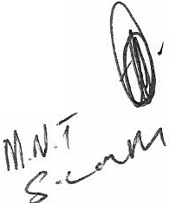the mere fact that a particular function, power or duty conferred upon or assigned or delegated to the Employee is not contained in Annexure A, does not release the Employee from the responsibility to perform such function, exercise such power and discharge such duty, as the case may be, to the best of his ability. The inclusion of a specific performance objective or performance target in the Employee's performance plan does not replace, reduce, substitute or in any other manner interfere with the Employee's obligation to perform the functions, exercise the powers and discharge the duties, as the case may be, which may have been conferred upon or assigned or delegated to him in any other manner. Nothing in this agreement diminishes the

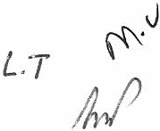2IMOHOK A RE L O C AL M UN I C IP A LITY

:21)\2/21!13 .

- h<'

Employee's obligations, duties or accountability in terms of his employment contract or
existing or new regulations, circulars, policies , directives or other instruments .

PERFORMANCE MANAGEMENT SYSTEM

  - The Employee agrees to participate in the performance management system that the Employer adopts or introduces for the Employer, management and municipal staff of the Employer.

  - The Employer will consult the Employee about the specific performance standards that
will be included in the PMS as applicable to the Employee

  - The Employee's assessment will be based on his performance in terms of outputs (performance targets) reflected on the Performance Plan which are linked to relevant KPA's /CCRs, key objectives and key performance indicator s (KPis) as agreed to between the Employer and the Employee.

  - The criteria upon which the performance of the Employee shall be assessed shall consist of two components with a weighting of 80:20, as indicated in Annexure A, namely-
    - Key performance areas at 80%; and
    - Core competency requirem ents/Core Managerial Competencies (CMC) at 20%

  - The Employee's assessment will be based on his performance in terms of the outputs/ outcomes (performance indicators) identified as per attached Performance Plan ( Annexure A), which are linked to the KPAs, and will constitute 80% of the overall assessment results as per the weightings agreed to between the Employer and Employee.

KEY PERFORMANCE AREAS (KPA's) | WEIGHTING
Basic Service Delivery | 40 %
Municipal Institutional Development and Transformation | 20 %
Local Economic Development (LED) | 15 %
Municipal Financial Viability and Management | 15 %
Good Governance and Public Participation | 10 %
Total | 100%

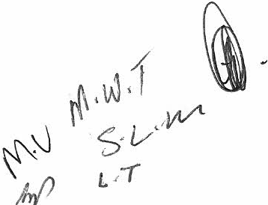3I MOJIOKARE L OCAL MUNICIPALITY

  - The CCRs will make up the other 20% of the Employee's assessment score. CCRs that are deemed to be most critical for the Employee's specific job should be selected from the list below as agreed to between the Employer and Employee:

CORE MANAGERIAL COMPETENCIES | WEIGHT
Financial Management | 10
People Management and Empowerment | 20
Client Orientation and Customer Focus | 20
Strategic Capability and Leadership | 10
Problem Solving and Analytical Thinking | 10
Programme and Project Management | 10
Competency in Policy Conceptualisation and Implementation | 10
Honesty and Integrity | 10
 | 100%

EVALUATION PERFORMANCE

  - The performance plan (Annexure A) to this agreement sets out-

    - The standards and procedure for evaluating the Employee's performance; And
    - The intervals for the evaluation of the Employee's performance.

  - Despite the establishment of agreed intervals for evaluation, the Employer may in addition review the Employee's performance at any stage while the contract of employment remains in force.

  - Personal growth and development needs identified during any performance review discussion must be documented in a Personal Development Plan as well as the actions agreed to and implementation must take place within set time frames.

  - The Employee's performance will be measured in term s of contributions to the goals and
strategies set out in the Employer's IDP.

  - The annual performance appraisal will involve:

    - Assessment of the achievement of results as outlined in the performance plan :
      - Each KPA should be assessed according to the extent to which specified standards or performance indicators have been met and with due regard to ad hoc that had to be performed under the KPA.
      - An indicative rating on the five-point scale detailed in Annexure A should
be provided for each KPA.
      - 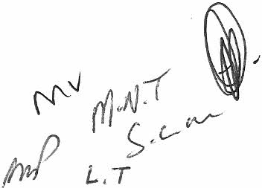The applicable assessment rating calculator (refer to paragraph 6.5 above) must then be used to add the scores and calculate a final KPA score.

4I MO IIOK ARE L OCAL MUNl C IPALlTY

    - Assessment of the CMC's

      - Each CMC will be assessed according to which the specified standards have been met
      - An indicative rating on the five-point scale will be provided for each CMC.
      - This rating will be multiplied by the weighting given to each CMC to provide score
      - The applicable assessment rating calculator will then be used to add the scores and calculate a final CMC score

    - Overall rating

An overall rating will be calculated by using the applicable assessment rating calculator. Such overall rating represents the outcome of the performance appraisal.

PERFORMANCE ASSESSMENTS

  - The Employee's performance shall be assessed after the end of each quarter, as follows -

Quarter |  | Assessment before
1 | July- September | 30 S tember 2012
2 | October - December (hereinafter referred to as " the mid-year performance review'') | 31 January 2013
3 | Tanuary - March | 30 April 2013
4 | April - June (hereinafter referred to as "the annual performance appraisal") | 31 July 2013

  - The Employee's mid-year performance reVlew and annual performance appraisal shall be
conducted by an evaluation panel consisting of-

    - The Municipal Manager
    - The Chairperson of the performance audit committee or, if the Employer does not have a performance audit committee, the audit committee
    - A councillor of the Employer's Council designated by the Council
    - The municipal manager of another municipality designated by the Municipal Manager;
    - Ward Committee member
    - The Municipal Manager has the priority to ask external consultants/ expects to conduct the entire evaluation.

  - The assessments for the first quarter Guly- September) and the third quarter Ganuary - March) shall be conducted by the Municipal Manager, provided that the Municipal Manager may request any member(s) of the evaluation panel to assist him during such assessment

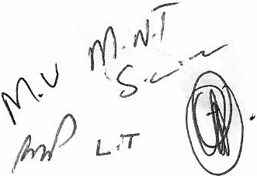5j MO HO KARE L OC A L MUNICIPALITY

'··..:
'
) I ) ()1' ' ' ' ' ' y
">j
I?
- -!- ' .
"'1
,· /;;:. ·..:\A: ,.. ·... . ·r,. '·· ·::..

  - The assessment of the performance of the Employee will be based on the following rating scale for KPA's and CMCs.

Level Terminology Description Rating
1121314 1 5

5 Outstanding
performance

4 Performance significantly expectations

3 Fully effective

above
The performance far exceeds the standard expected
of an employee at this level. The appraisal indicates that the Employee has achieved above fully effective results against all performance criteria and indicators as specified in the PA and performance plan and maintained this in all areas of responsibility throughout the year.
Performance 1s significantly high er than the
standard expected in the job. The appraisal indicates that the Employee has achieved above fully effective results against more than half of the performance criteria and indicators and fully achieved all others throughout the year.
Performance fully meets the standard s expected in all areas of the job . The appraisal indicates that the Employee has fully achieved effective results against all significant performance criteria and indicator s as specified in the PA and Performance Plan

2 Performance not fully
effective

1 Unacceptable
performance
Performance is below the standard required for the job in key areas. Performance meets some of the standards expected for the job. The review/assessment indicates that the Employee has achieved below fully effective results against more than half the key performance criteria and indicators as specified in the PA and Performance Plan. Performance does not meet the standard expected for the job. The review/assessment indicates that the Employee has achieved below fully effective results against almost all of the performance criteria and indicators as specified m the PA and Performance Plan. The employee has failed to demonstrate the commitment or ability to bring performance Plan. The employee has failed to demonstrate the commitment or ability to bring performance up to the level expected in the job despite management efforts to encourage improvement

    - The mid-year performance review and annual performance appraisal shall involve -
Assessment of the achievement of key performance indicators and targets in the key performance areas:
      - Each key performance area shall be assessed according to the extent to which the performance indicators have been met with due regard to ad hoc tasks that may have been performed under any key performance area.
      - An indicative rating on the five - poin t scale set out in clause 8.4 shall be provided for
each key performance area.
      - 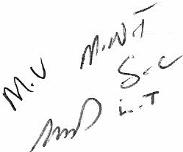The rating contemplated in paragraph (b) shall be multiplied by the weighting given to each key performance area to provide a score.

6I MOHOKARE LOCAL MUNIC I P A LITY

: . r· ' I• • ' ' -
"£ :\;,·,·;;,·,d i>crfou;t, ll ·,, ;\g·,·,. 'lllt'nt:.l\Lm,t<>t'
. . .

·th'Accounuhll' to th :\lunicip.tl.l\l.tn.t!!;l'l" . ··
l Dirt·t
' ·' I ' ' <
20i2/20l3 .... ...· '
·
'

:i:; s1 - : : ;:· : .;;_: : :.. ----- :..:,:·· .:- =- : · ::.. · .: ·.· f > : - <{ ·):· _; :::: - - -. .::. ;-j : . ./ .:·
:
-- ::.j-. - u
.. ..:..··,:. . ..'•., '...... .

      - The assessment rating calculator shall be applied to add the scores and calculate a final key performance area score.

  - The employer shall keep the a record of the mid- year review and annual assessment meetings

  - Performance feedback shall be based on the Employer's assessment of the Employee's performance.

  - The employer will be entided to review and make reasonable changes to the provlSlon s of Annexure A from time to time for operational reasons. The Employee will be fully consulted before any such change is made.

  - The employer may amend the prov1s10ns of Annexure A whenever the performance management system is adopted, implemented and/or amended as the case may be. In that case the Employee will be fully consulted before any such change is made.

  - The Employer must -
    - Keep a written record of the mid-year review and annual appraisal meetings, and
    - Cause secretarial services to be provided to the evaluation panel

  - Despite the establishment of agreed intervals for evaluation as set out in clause 8.1 above, the Employer may in addition review the Employee's performance at any time whilst this Agreement remains in force.

  - The Employer shall supply a copy of any assessment in terms of this clause to the Employee within a reasonable time after such assessment has been completed and shall invite the Employee to attend and participate in a performance interview, which shall be conducted by the Municipal Manager, provided that the Municipal Manager may request any member(s) of the evaluation panel to assist him during such an interview. A performance interview shall be conducted within 30 days after the date on which the Municipal Manager or the evaluation panel, as the case may be, has conducted a performance review or assessment, on a date agreed between the Parties.

  - The Employee has the righ t, during a performance interview, in respect of any performance
objective, target or core competency requirement to -
    - Request and receive an explanation for any points awarded;
    - Submit additional and/or supplementary evidence of performance/achievement; and
    - Provide an explanation for any below standard performance

DEVELOPMENTAL REQUIREMENTS

The Personal Development Plan (PDP) for addressing developmental gaps 1s attached as

Annexure B.

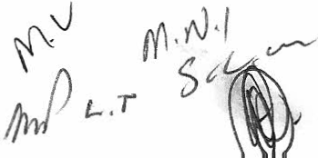7I MO H OKARE LO CA L MUNICIPALITY

OBLIGATIONS OF THE EMPLOYER

  - The Employer shall -
    - Create an enabling environment to facilitate effective performance by the employee;

    - Provide access to skills development and capacity building opportunities;
    - Work collaboratively with the Employee to solve problems and generate solutions to
common problems that may impact on the performance of the Employee;
    - On the request of the Employee delegate such powers reasonably required by the Employee to enable him to meet the performance objectives and targets established in terms of this Agreement; and
    - Make available to the Employee such resources as the Employee may reasona bly require from time to time assisting him to meet the performance objectives and targets established in terms of this Agreem ent.

CONSULTATION

  - The Employer agrees to consult the Employee timeously where the exercising of the
powers will have amongst others -

    - A direct effect on the performance of any of the Employee's functions;
    - Commit the Employee to implement or to give effect to a decision made by the
Employer; and
    - A substantial financial effect on the Employer.

  - The Employer agrees to inform the Employee of the outcome of any decisions taken pursuant to the exercise of powers contemplated in 11.1 as soon as is practicable to enable the Employee to take any necessary action without delay.

MANAGEMENT OF EVALUATION OUTCOMES

  - The evaluation of the Employee's performance will form the basis for rewarding outstanding performance or correcting unacceptable performance.
  - A performance bonus of 5% to 14% of the inclusive annual remuneration package may
be paid to the Employee in recognition of outstanding performance.
  - The Employee will be eligible for progression to the next higher remun eration package, within the relevant remuneration band, after completion of at least twelve (12) months service at the current remuneration package on 30 June (end of financial year) subject to a fully effective assessment.
  - In the case of unacceptable performance, the Employer shall-
    - Provide systematic remedial or developmen tal support to assist the Employee to
improve his performance; and
    - After appropriate performance counselling and having provid ed the necessary guidance and/ or support as well as reasonable time for improvement in performance, the Employer may consider steps to terminate the contract of employment of the Employee on grounds of unfitness or incapacity to carry out his duties.

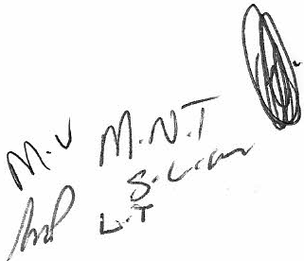SI MO H OKARE LOCAL MUNI CI P AL ITY

  - A performance bonus calculated as a percentage of the Employee's all-inclusive annual remuneration package may be paid to the Employee in recognition of outstanding performance, as follows:

Score | Performance bonus
129% | 0%
130% | 5%
133% | 5%
135% | 6%
137% | 6%
138% | 7%
140% | 8%
142% | 8%
143% | 8%
145% | 8  9 | %
147% |  | %
148% | 9%
150% | 10%
152% | 10%
153% | 10%
155% | 14%

  - Any performance bonus that may be payable to the Employee, shall only be paid out
after-
    - 30June 2013
    - The Employer's Council has approved the Employee's annual performance
appraisal as required by section 57(4B) of the Systems Act; and
    - The annual report relating to the 2012/2013 has been tabled in the Employer's
Council and the Council adopted it.

  - In the case of unacceptable performance, the Employer-
    - Shall provide systematic remedial or developmental support to assist the Employee to
improve her performance; and
    - May, after appropriate performance counselling and having provided the necessary guidance and/or support as well as reasonable time for improvement on grounds of unfitness or incapacity to carry out his duties.

DISPUTE RESOLUTION

  - Any disputes about the nature of the Employee's performance agreement, whether it relates to key responsibilities, priorities, methods of assessment and/ or any other matter provided for, shall be mediated by the Mayor within 30 days of receipt of a formal dispute.
  - A decision by the Mayor in terms of clause 13.1 shall be final and binding on the Parties

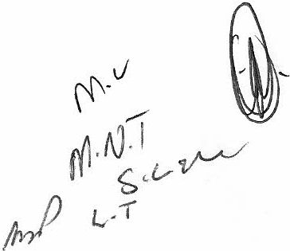9 IMOHOKARE LO CAL MUN I C IP AL I TY

: , ;:._- (,:- - ·,· , ' : . ·. . . '
l
l
I
/ } Jlt_• · \ I c f< ·•.n·!llc · _Agtccmn t: l\l.tll:tgcrs Directly Accounuble to the l\luniCJp.tll\Ltnager
E : -+i" ttr; .; iik ;:<l /¥:·H-( .. ·· · , . - ..... ., · .. ;. · . · . ...· ·

14. GENERAL

14.1 The Employer shall make the contents of this agreement available to the public.
14.2 The Employer may make the outcome of any performance review, evaluation or appraisal conducted in terms of this agreement available to the public.

Thus done and signed at....?!!. !1-.0.:.........one?. 7. ::J...2012

AS WITNESSESS:

1.

Thus done and s1.gned at ....:.2../.l..s./.".T.{.o..N...... .....on,.;..;.7..J.-l.-f.-L..:.J...2012

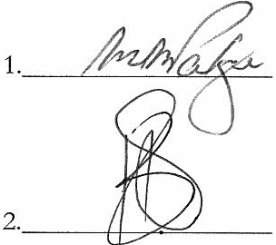AS WITNESSESS: 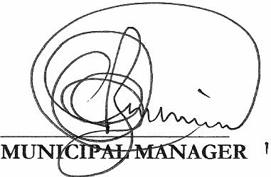

10 IM 0 I-I 0 K A R E L 0 c A L M u N T c Ip A L [ T y

PERSONAL PERFORMANCE PLAN 2012/13: DIRECTOR TECHNICAL SERVICES
ANNEXURE A

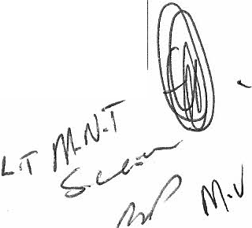

KEY PERFORMANCE AREA: BASIC SERVICES

Performance objective [Main tasks] | Weight l<ey Pel"formance Indicator Tm·get Date [Evidence of performance) |  |  |  | Achievements /Prog•·ess I |  |  | Rating
 |  |  |  |  | Comments/Reference to
 |  |  |  |  |  | evidentiary documents
To provide trafficable roads/ routes and functional streets | 40  \ | Upgraded internal roads/ routes and storm  water in Zastronj Matlakeng | 30 June 2013
 |  | Upgraded internal roads/ routes and storm  water in Rouxville/ Roleleyathunya | 30 June 2013
 |  | Upgraded internal roads/ routes and storm water in Smithfield/ Mofulatshepe | 30 June 2013
To provide a safe and  sustainable sanitation management and infrastructure development |  | 152 household with access to water borne  toilets in Matlakeng | 31 July 2012
 |  | 52 household s with access to water borne  toilets in Mofu latshepe | 31 July 2012
 |  | Meet SANS standards and requirements (Green  Drop Compliance) | 30 June 2013
 |  | All formal households with access to basic to basic sanitation services | 30 June 2013
To provide world class up-to-  standard water services to promote development and fulfil basic service needs |  | All formal households with access to ba sic water  service | 30 June 2013
 |  | Implementing a water leak tracing and fixing in the network | 30 June 2013
 |  | Meet SANS standards and requirements (Blue Drop Compliance) | 30 June 2013
 |  | , Complete construction and upgrade of the water  itreatment works in Rouxville | 31 March  2013
 |  | Development of the Water Services  Development Plan (WSDP) | 30 June 2013
 |  | Development of an Operation and Maintenance  plan(water) | 30 June 2013

Performance objective Key Performance Indicato1· Achievements jProg1·ess I
[Main tasks] Weight (Evidence ofperfonnanceJ Target Date Comments/Reference to Rating
evidentiary documents

Completion of an electricity asset register 30 June 2013 Provision of electricity to 209 households in 30 March
An effective management of Smithfield/ Mofulatshepe 2013
electricity supply to residents Provision of households with solar heating 30 June 2013
panels
Development of business plan of 16 high mast
lights and 66 street lights in Refengkhotso, 30 June 2013 Ezibeleni and Phomolong

TOTAL

KEY PERFORMANCE AREA: LOCAL ECONOMIC DEVELOPMENT

Pet·fonnance objective Key Perfomtance Indicator Achievements/Pt·ogress/
[Main tasks] Weight (Evidence ofperfonnance] Ta1·get Date Comments/Reference to Rating
evidentia1·y documents
Ensure that proj ects are 15 Bid specifications for construction projects designed to prefer labour contain conditions relating to:
intensive construction Employing local labour; and On-going
methodologies, in accordance Engaging local sub-contractors
with the EPWP

TOTAL

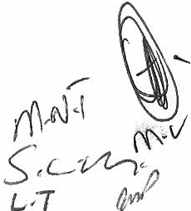

KEY PERFORMANCE AREA: MUNICIPAL INSTITUTIONAL DEVELOPMENT AND TRANFORMATION

Performance objective Key Performance Indicator AchievementsjProgr·essj
[Main tasks] Weight (Evidence ofped·onnance( Target Date Comments/Reference to Rating
evidentiary documents
Improve the Municipality's 20 Establish and staff the project management un it
project management capacity On-going

Employees assigned to the Nominat ion and attendance records of
Department undergo training employees who attended training On-going in terms of the approved
workplace skills plan

Submissions/ reports/ items Register of submissions/ reports/ items for submission to the Council or received at Corporate Services
a committee are submitted to
the Director: Corporate On-going
Services at least 7 working days
before the date of the relevant
meeting

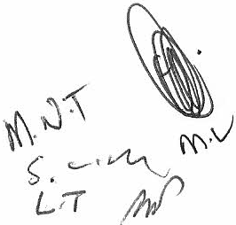

KEY PERFORMANCE AREA: MUNICIPAL FINANCIAL VIABILITY AND MANAGEMENT

Pet·fonnance objective Key Perfonnancc Indicator Achievements /Pmgt·css/
IMain tasl<s] Weight (Evidence ofperfonnance] Target Date Commentsj Refet·ence to Rating
evidentiary documents
Suppliers engaged by the 15 Set input, output and outcome indicators for
Department meet performance each service-provider appointed for the On-going
standards in terms of quality, Department
budgets and timelines Measure performance of service-providers On-going
against agreed indicators
No irregular, unauthorised or No expenses incurred byI on behalf of the
fruitless and wasteful Department are disallowed for being irregular, On-going
expend iture is committed, unauthorised or fruitless and wastef ul
made, authorised or incurred
Expeditiously respond to Written response to audit queries and variance
internal and external audit reports are submitted within 5 working days As and when
enquiries relating to the after receipt required
department
Contract variations are Documented contract variations comprehensive ly documented ,
approved and annexed to the As and when
principal contract as a properly required
executed and signed addendum

TOTAL

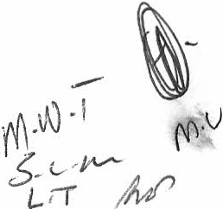

KEY PERFORMANCE AREA: GOOD GOVERNANCE AND PUBLIC PARTICIPATION

Perfonnance objective Key Performance lndicatm· Achievements / Progress/
I

!Main tasks]
Weight
Evidence of performance]
Target Date Comments /Reference to Rating
evidentiary documents

10 Attendance of Public and sector engagement
Promotion of the Good meetings for d evelopment of IDP, SDBIP and On-going
governance principl es Budget, etc.

Submis sions of report to Corporate Services for
publi cation to community and other As and when
stakeholders requi red

Enhancement of Atten dance of meetings in line with the
Intergove rnm ental relation s Intergovernmental Relations Framework Act On-going
No. 13of2005

TOTAL

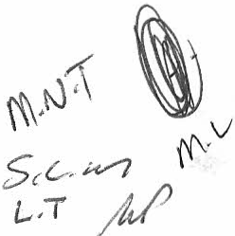

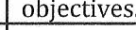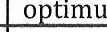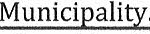CORE COMPETENCY REQUIREMENTS

Financial management

People management and
Compiles and manages budgets, controls cash flow, institutes risk management and administers supply
chain management processes in accordance with
10 legal prescripts and generally recognised accounting
practices in order to ensure the achievement of the
Mu
Manages and encourages people, optimises their

empowerment 20
Client orientation and customer
focus 20
Strategic capability and
leadership 10

Problem solving and analysis

10

Programme and project
outputs and effectively manages relationships in order to achieve the Municipality's strategic

Willing and able to deliver services effectively and efficiently in order to put the spirit of customer service (Batho Pete1 into nr,rtirA
Provides a vision, sets the direction for the administration and inspires others to deliver on the municinalitv's mandate
Systematically identifies analyses and resolves
existing and anticipated problems in order to reach
m solutions in a timelv manner.
Plans, manages, monitors and evaluates specific

management

Honesty and integrity

Competence in policy conceptualisation, analysis and implementation
10 activities in order to deliver the desired outputs and
outcomes.
Displays and builds the highest standards of ethical
10 and moral conduct in order to promote confidence and trust in the
The ability to draft and implement a policy due to the arriving at a concept or a generalisation as a
result of seeing things, experiencing things, being
10 informed of something as well as the ability to
analyse, comprehend and implement a policy drafted bv somebodv else.

TOTAL

f{\ tJ :( (fu_.
,. . v
..::.kv· J/1/l ·
[...:I ,4,P

RATING ASSESSMENT CALCULATOR KEY PERFORMANCE AREAS
Key performance area | Weight | Rating | Score
Basic Service Delivery | 40
Municipa l Institutional Development and Transformation | 20
Local Economic Development | 15
Municipal Financial Viability and Management | 15
Good Governance and Public Participation | 10
Total score
Total weight, key performance areas |  |  | 80%
Weighted score, Key performance areas

CORE COMPETENCY REQUIREMENTS

Core competency requirement |  | Weight | Rating | Score
1 | Financial management | 10
2 | People management and empowerment | 20
3 | Client orientation and customer focus | 20
4 | Strategic capability and leadership | 10
5 | Problem solving and analysis | 10
6 | Programme and project management | 10
7 | Honesty and integrity | 10
8 | Competence in policy conceptualisation , analysis and implementation | 10
 | Total score
 | Total weight, core competency requirements |  |  | 20%
 | Weighted score, core competency requirements

